**Hack The Feed: Insights From Social Media Data Report.**

**Introduction**

In this Report, the aim is enhancing online engagement and optimizing digital presence. By delving into the nuanced interplay of content types on platforms such as Instagram, Facebook, Twitter, and LinkedIn, the aim is to extract actionable insights that will empower informed strategic decisions.

The objective is to explore comprehensive data analyses, uncover trends, and patterns that illuminate the path toward heightened engagement. Through this report, the goal to refine digital marketing strategies, achieving more impactful and resonant interactions with target audience.

**Key Findings**

1. **Instagram Engagement:**

* Posts shared in May stands out as the month with the highest Instagram engagement, surpassing all other months.
* In 2022, Instagram witnessed its highest-ever engagement compared to previous years.

1. **Facebook Posting Timing:**

* For optimal post engagement on Facebook, consider posting between 6 AM and 4 PM, with a peak at 12 AM.

1. **LinkedIn Content Types:**

* Photo posts are the most common on LinkedIn.
* However, polls generate the highest engagement on the platform.
* The peak engagement period on LinkedIn occurred in September 2020.

1. **Twitter Engagement:**

* Twitter engagement demonstrates a consistent upward trend.
* The highest historical engagement on Twitter was recorded in 2019.

**Key Insights**

1. **Instagram Content Types:**

* Videos on Instagram enjoy the highest engagement, indicating a preference for video content among the audience.

1. **Facebook Content Types:**

* Photos receive the most likes on Facebook, highlighting a preference for photo-based content on the platform.

1. **LinkedIn Content Types:**

* Polls on LinkedIn generate higher engagement than photo posts, suggesting a greater interest in polls among the LinkedIn audience.

1. **Twitter Engagement Hours:**

* Twitter post engagement remains consistently high from 6 AM to 11 PM, peaking at 11 PM. This indicates that Twitter users are most active during these hours.

**Detailed Findings**

**Section 1**: **Social Media Platforms**

1. **Instagram**

* **Engagement Analysis:**
* Analysis shows a compelling trend in Instagram engagement, with posts in the month of May consistently surpassing other months in terms of overall engagements.

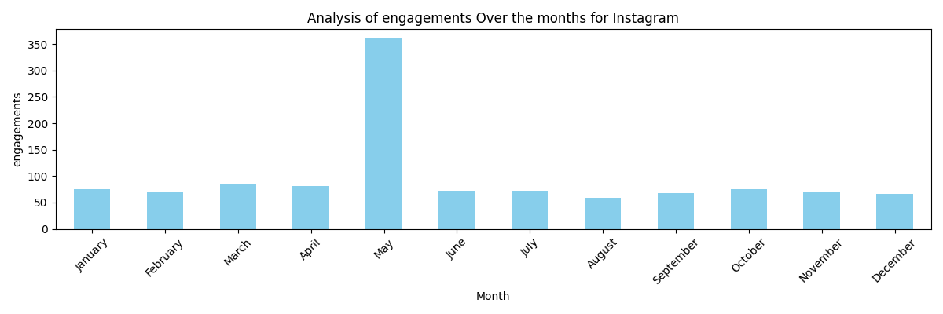

* **Engagement per Hour Insight:** Engagement on hourly basis shows that posts that were posted on 2 PM garners the highest engagement, followed closely by 10 AM and 9 PM.

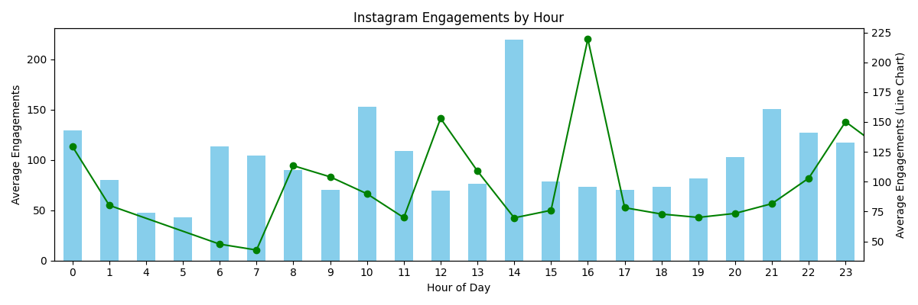

* **Yearly Engagement Peaks:** In terms of annual performance, Instagram witnessed its highest engagement levels in 2022, followed by the year 2019, signifying a substantial increase in engagement compared to other years.

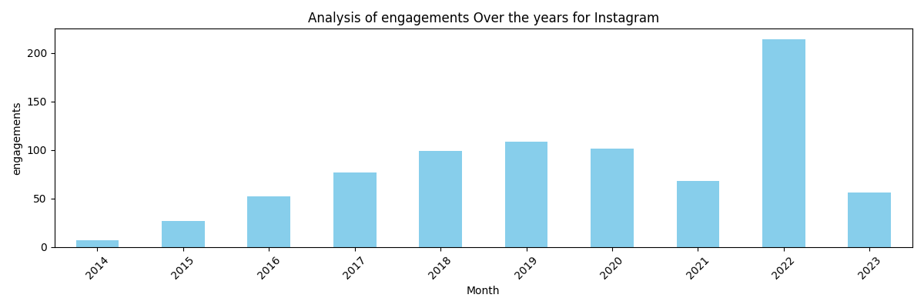

* **Remarkable Year 2022:** Notably, in 2022, Instagram experienced more than a 100% surge in engagements compared to previous years.

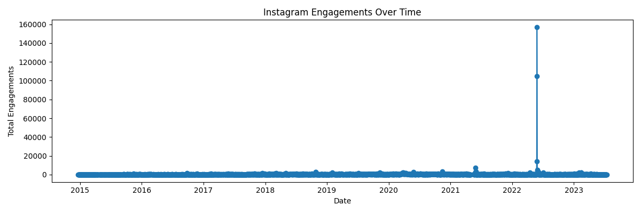

* **Likes Analysis:** The year 2022 recorded the most likes, followed by 2019, indicating a preference for content from these years.

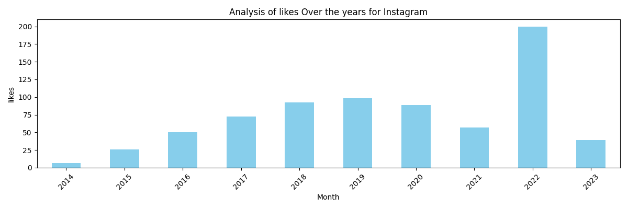

* **Monthly Likes:** The data demonstrates that the posts on month of May consistently stands out with the highest number of likes compared to other months. 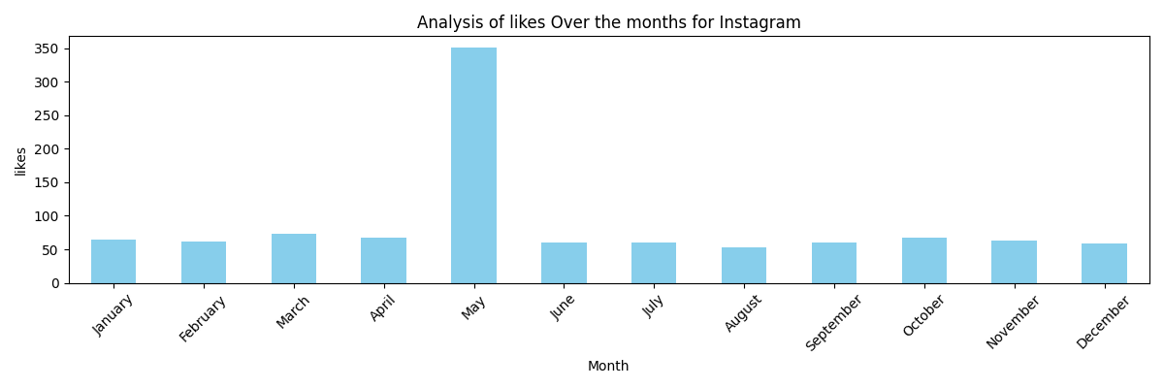
* **Reactions:** The analysis of Reactions per month shows that the posts in month of May have the most Reactions when compared to other months.

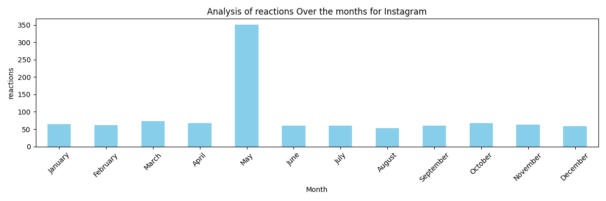

* **Yearly Reaction Trends:** The analysis of reactions over the years shows that the posts made in the year 2022 have the highest reactions, followed by 2019, indicating significant engagement spikes in these years.

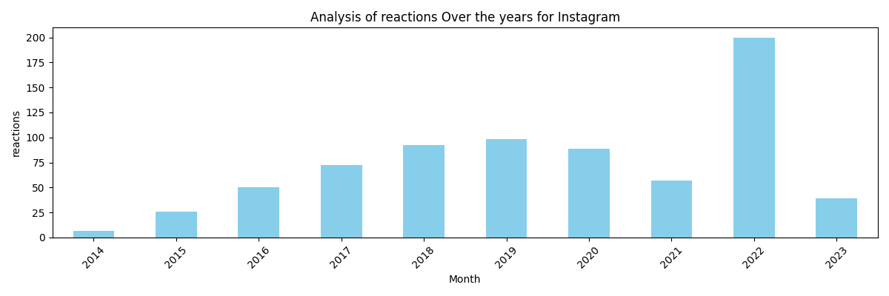

* **Content Type Impact:** Video content leads the pack with the highest number of reactions, engagements, and likes at 41.4%, surpassing other content types like Carousel and Photo.

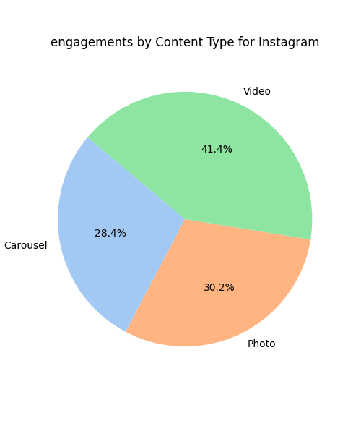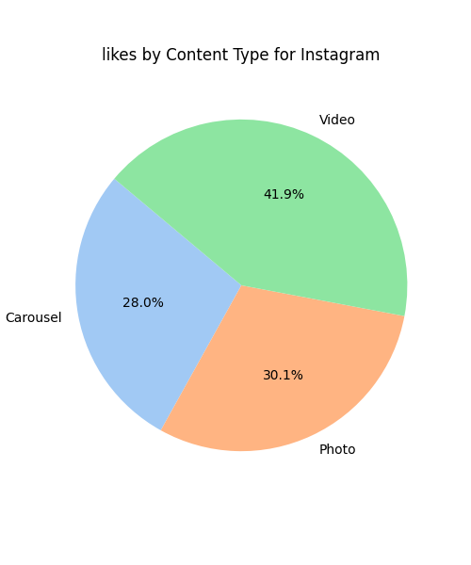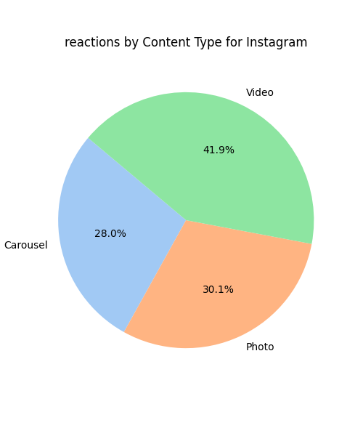

* **Fan Reach and Top Posts:** Posts related to "opening an account" achieved the highest fan reach and likes, underlining their success in engaging the audience.

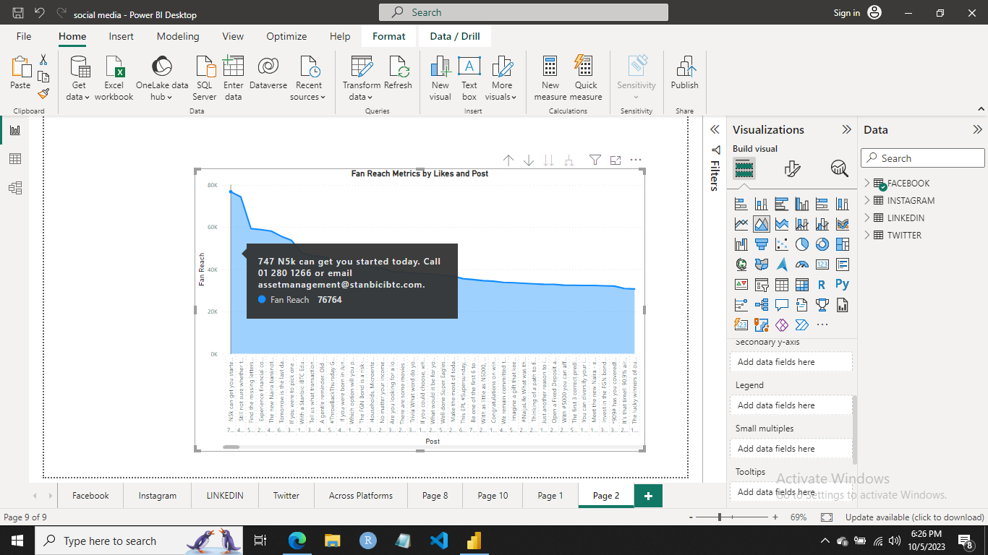

* **Deeper Insights on Instagram:** While Instagram boasts a higher volume of photo posts, these images also generate a substantial level of engagement. With a staggering 10,000 photo posts, the platform reaches an impressive audience of 13 million, resulting in 1 million engagements and 909 reactions and likes.
* **Most Engaging Content Type:** Even though the photo content type is posted more often than other content categories, video content regularly ranks as Instagram's most engaging format.

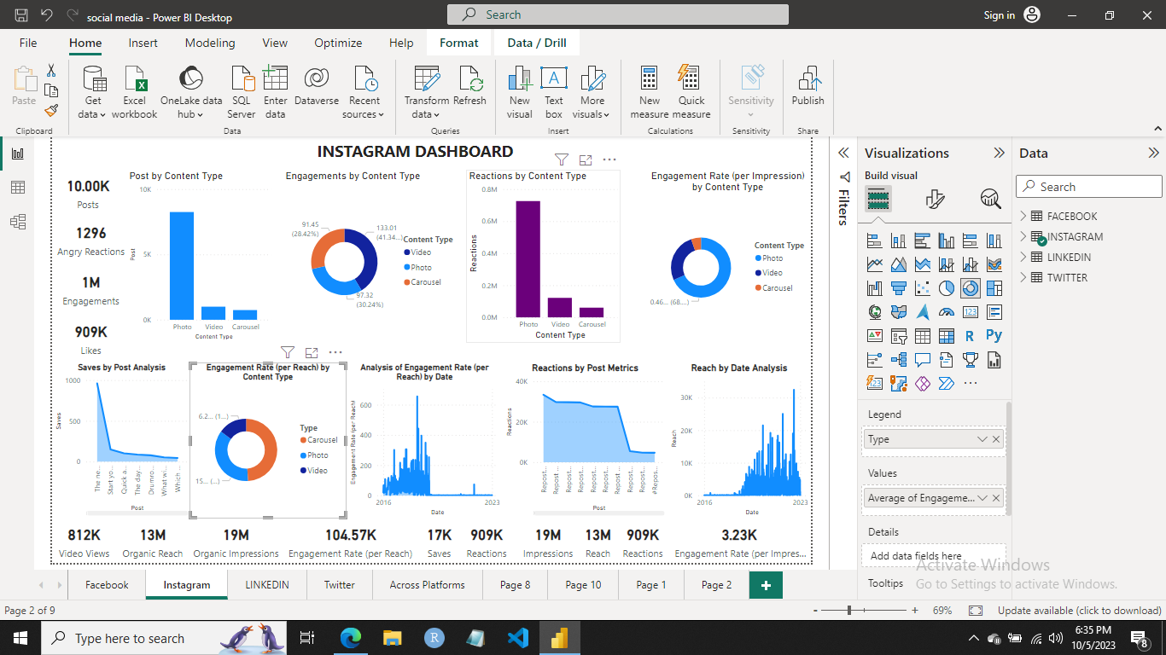

1. **Facebook**

* **Engagements Trends:** When analysing engagement per hour, findings indicate that posts engagements peak at 12:00 AM, closely followed by 9:00 PM.

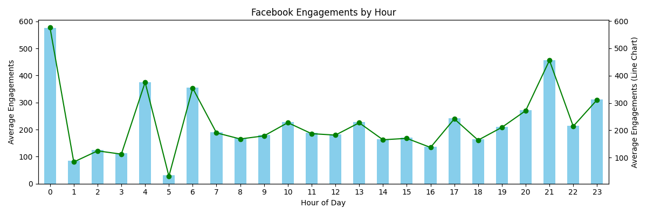

* **Historical Engagement Patterns:** Posts engagement analysis over time reveals that 2017 experienced the highest engagement levels, marking a remarkable 100% increase compared to other years.

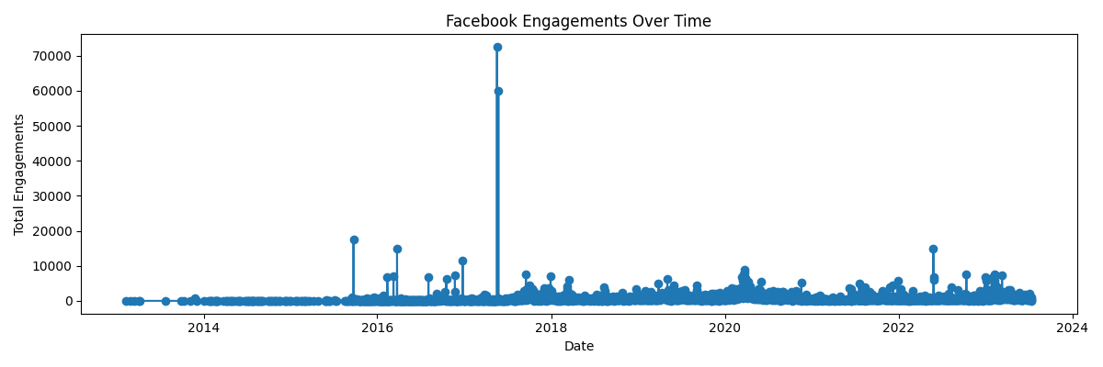

* **Likes on Facebook:** Photo content garners the most likes, suggesting a preference for this content type among users.

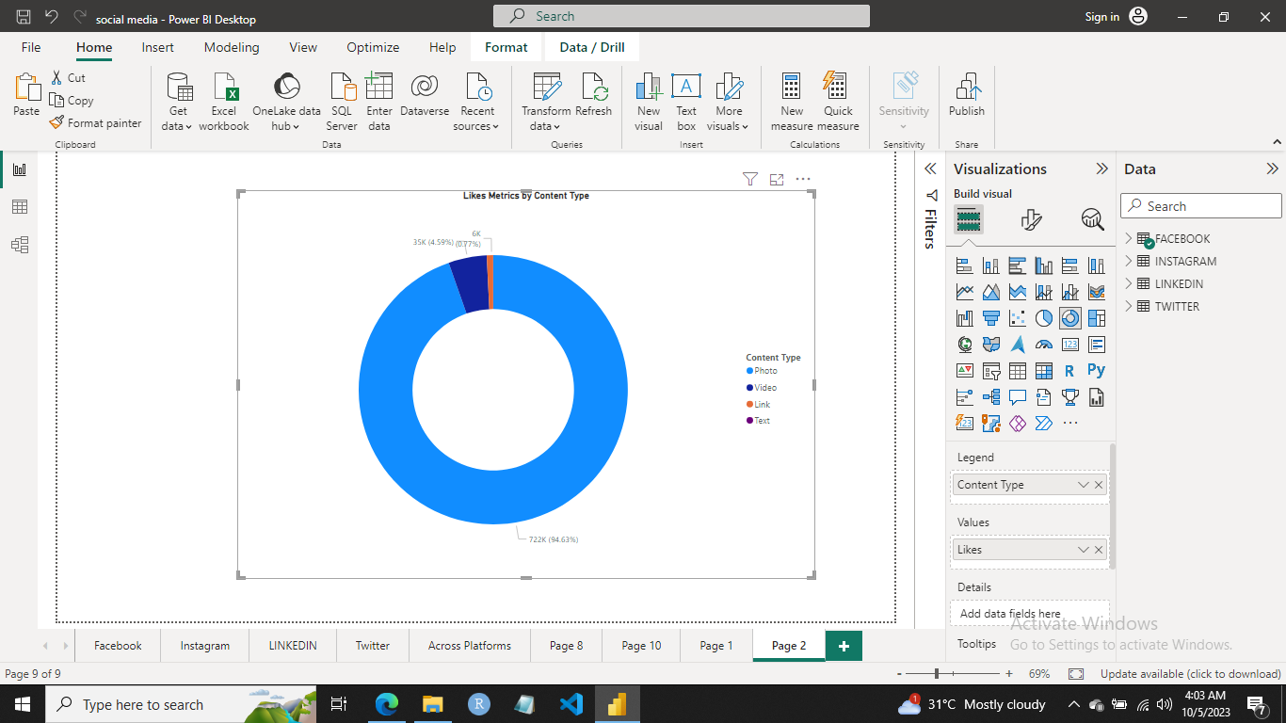

* **Content Type Preferences:** The data reveals that both engaged fans and users exhibit a distinct preference for photos over other content types such as Video, Links, and Text.

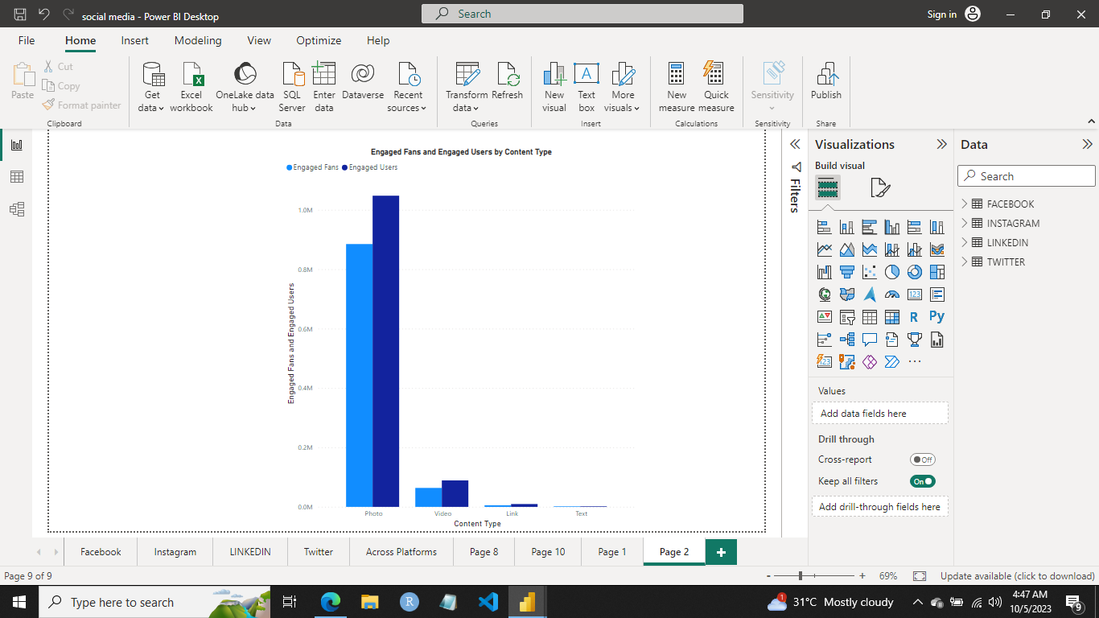

* **Deeper Insights on Facebook:** Diving into the specifics of Facebook engagement, our analysis unveils a total of 787,000 reactions, of which a staggering 743,000 stem from Photo content. Moreover, among the 763,000 likes recorded, a significant 722,000 are attributed to Photo content. This underscores the clear preference of engaged fans and users for Photo content over Video, Link, and Text content types.

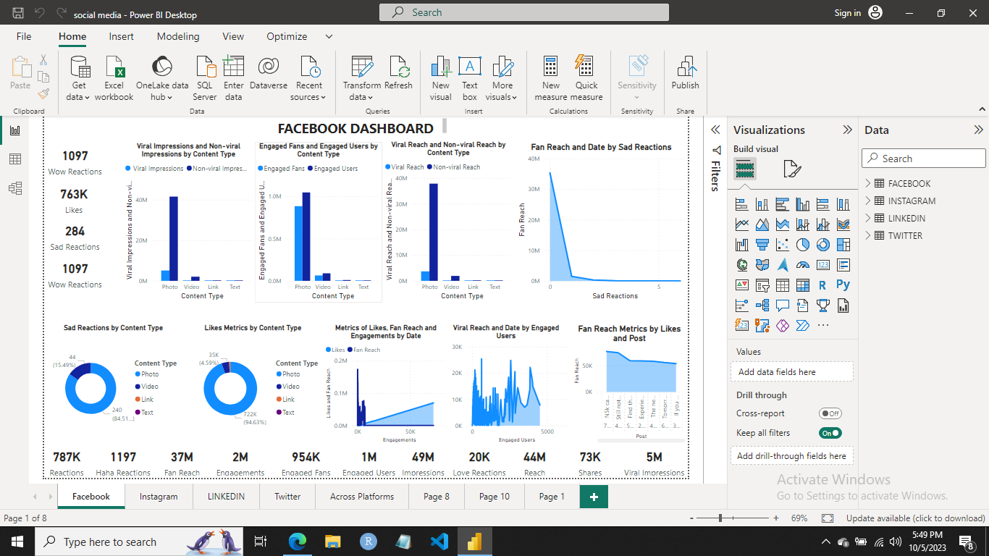

1. **LinkedIn**

* **Engagement Trends:** When examining posts engagement patterns per hour, our analysis indicates that engagement peaks at 1 AM, closely followed by 9 PM.

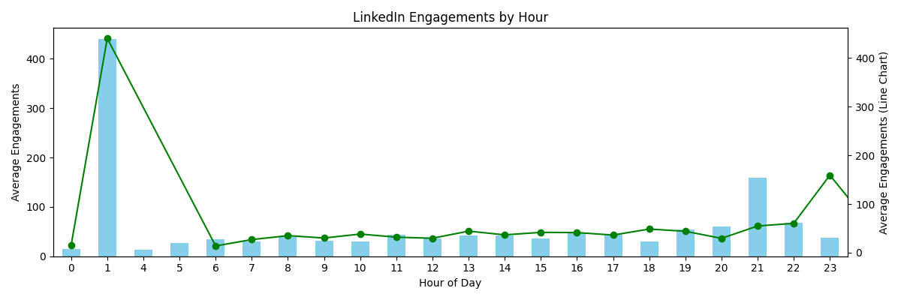

* **Historical Engagement Insights on LinkedIn:**  When examining the historical engagement of posts on LinkedIn over time, it is significant to highlight that the year 2022 stands out as the year with the most substantial post engagement levels compared to all other years.

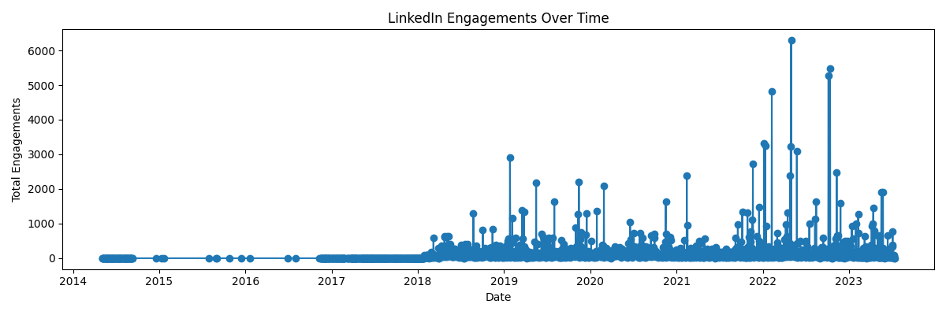

* **Content Type Analysis:** In terms of post engagement by content type, polls exhibit the highest level of engagement when compared to other content types such as Documents, Photos, Text, Videos, and Links.

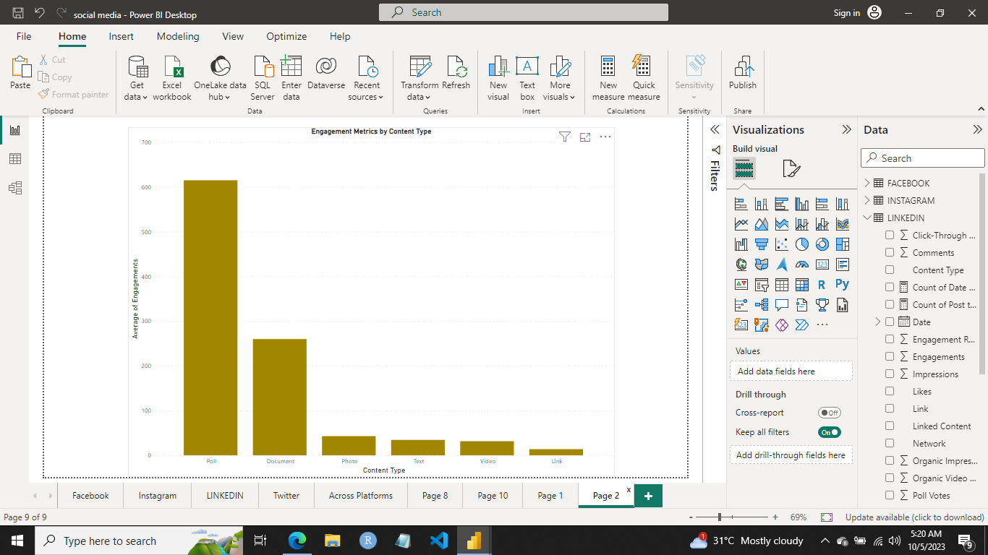

* **Reactions Analysis**: The peak of user reactions was achieved in September 2020, indicating a significant surge in user response, with a total of 3,813 reactions recorded during that period.

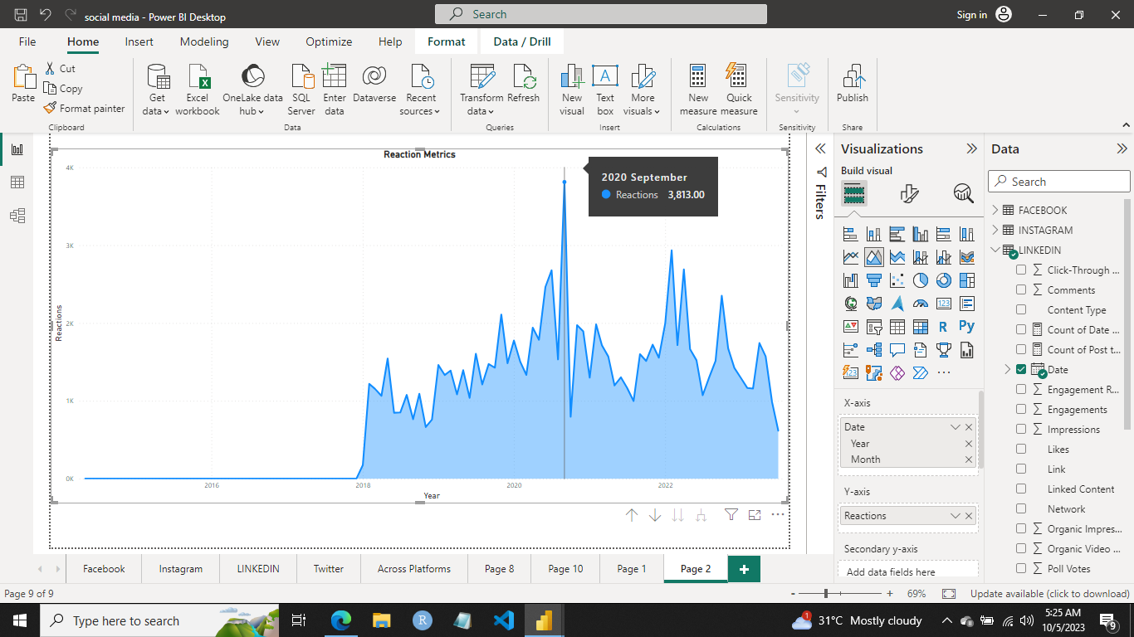

* **Posts Breakdown:** In terms of posting frequency, photo content takes the lead, surpassing other content types like Documents, Polls, Text, Videos, and Links.

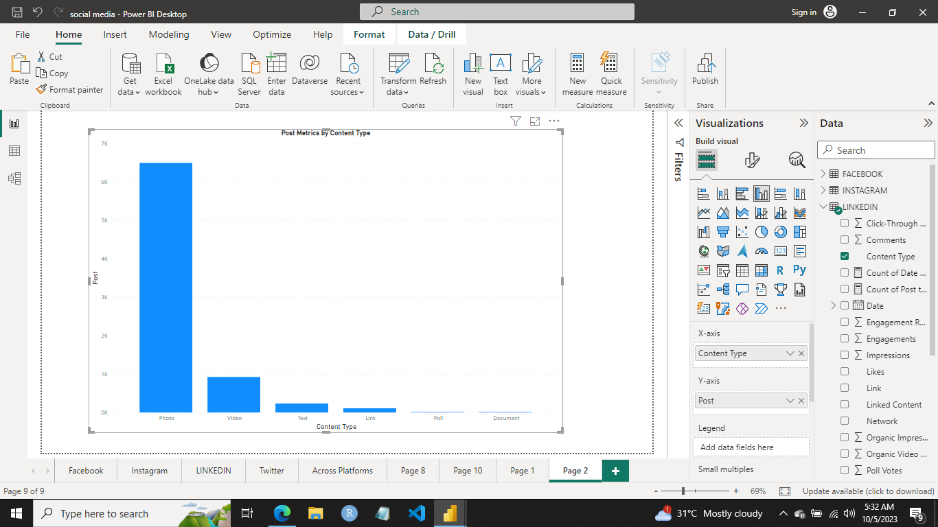

* **LinkedIn Insights:** On LinkedIn, polls consistently lead in terms of engagement, yet it's essential to highlight the frequent posting of photo content, showcasing a strategic and nuanced content approach on the platform.
* Additionally, when examining post engagement and reactions, we observe a significant uptick starting in 2018, indicating a clear upward trend. LinkedIn has amassed a total of 99,750 reactions and likes.
* It's noteworthy that in 2018, both the click-through rate and post engagement rate (per impression) reached their peak levels, underscoring the platform's performance and growth during that year.

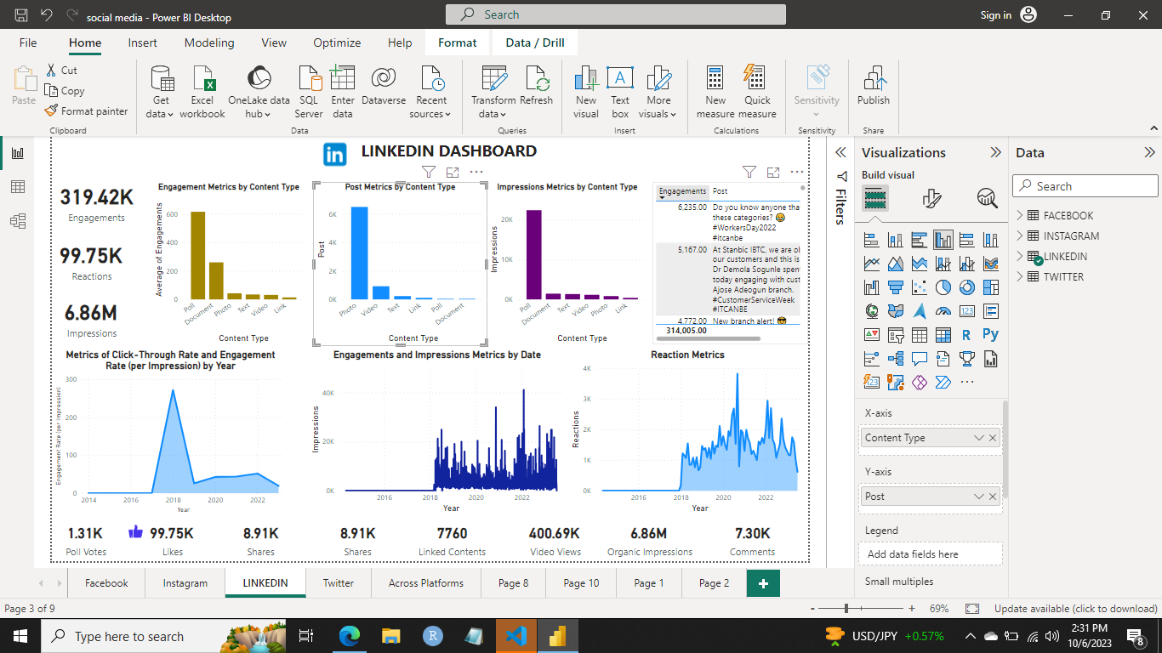

1. **Twitter**

* **Engagement Trends:** Analysing Twitter’s post engagement per hour, a clear upward trend in engagement is evident, beginning at 7 AM and peaking at 11 PM, with the highest engagement recorded at 11 PM.

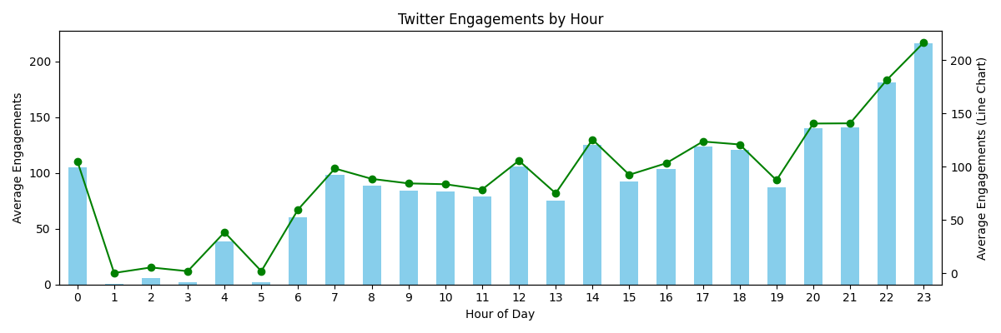

* **Twitter Engagement Over Time:** Twitter's engagement trends reveal an upward trend over time, punctuated by a noticeable gap in 2021 where no engagement was recorded. The peak of post engagement was achieved in 2019, marking a notable peak in user interaction.

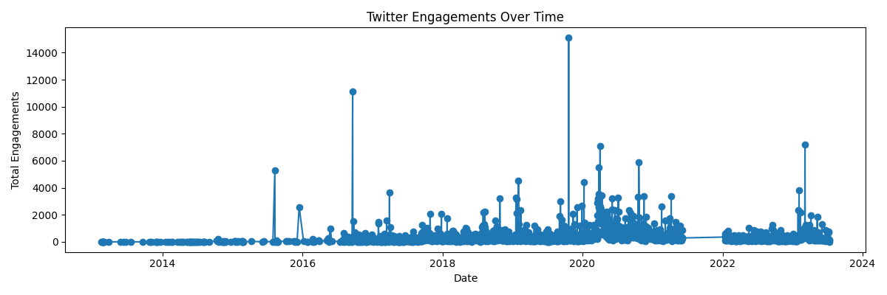

* **Content Type Insights:** The photo content type not only holds the distinction of being the most frequently posted but also enjoys the highest engagement among all content types.

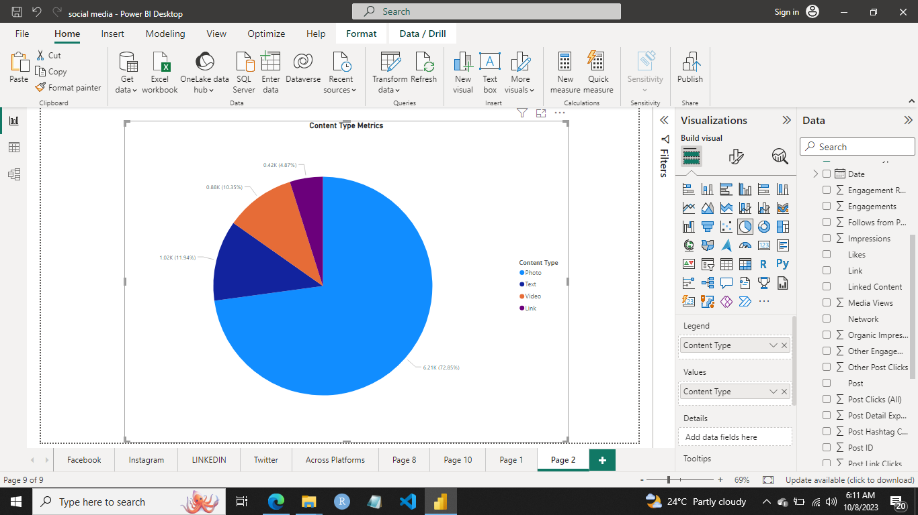

* **Media Views, Impressions and Tags Insight:** Our analysis highlights that posts without tags consistently attain the highest numbers in terms of impressions and media views.

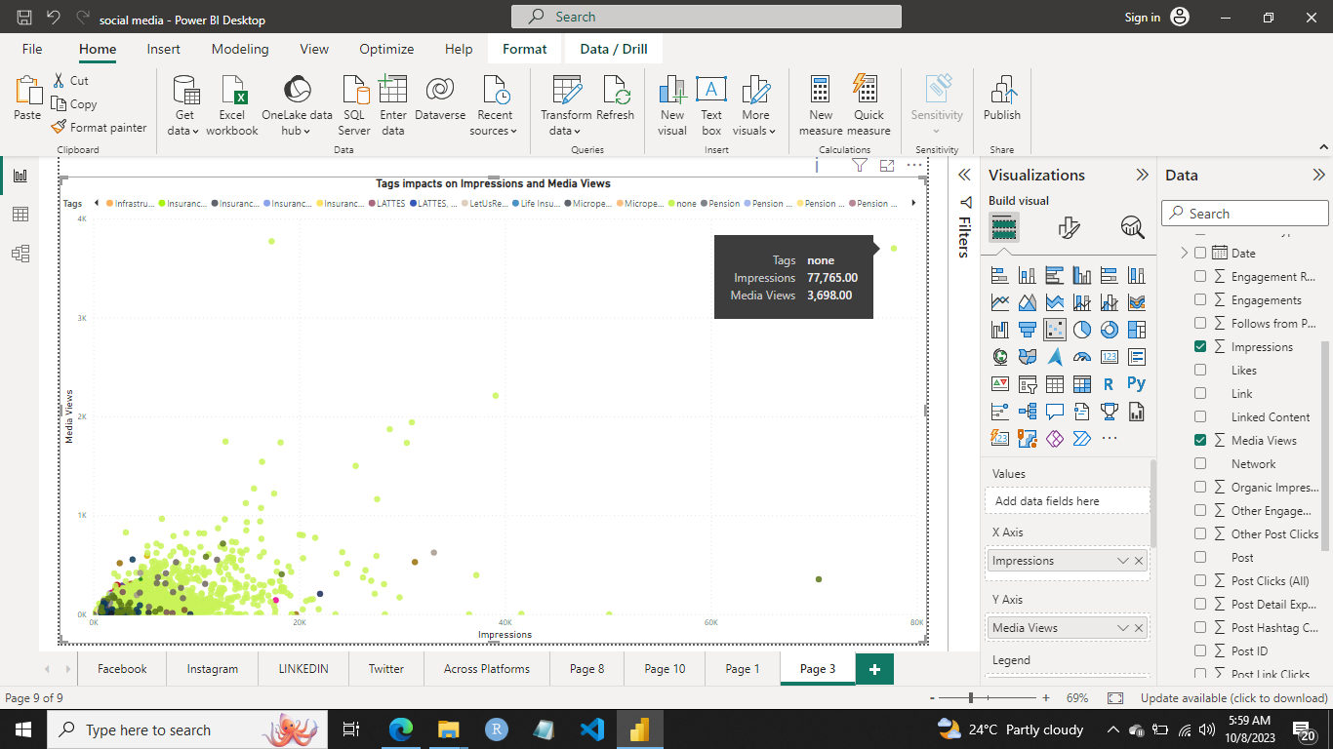

* **Twitter Insights:**
* On Twitter, we observe an impressive potential reach of 2.37 billion, accompanied by 158,490 reactions and likes, along with 65,230 shares. The platform boasts a substantial engagement count of 863,200.
* Delving into the content type specifics, photos stand out with an astonishing potential reach of 177 billion, coupled with 125,310 likes and reactions and a remarkable 690,350 engagements. Photos also lead the pack in Engagement per Impression, follows, and media views, underlining their effectiveness.
* It is noteworthy that likes outnumber shares on Twitter. Notably, Twitter achieved 21 follows from posts, this is the highest number of follows from a single post recorded on September 19, 2016.

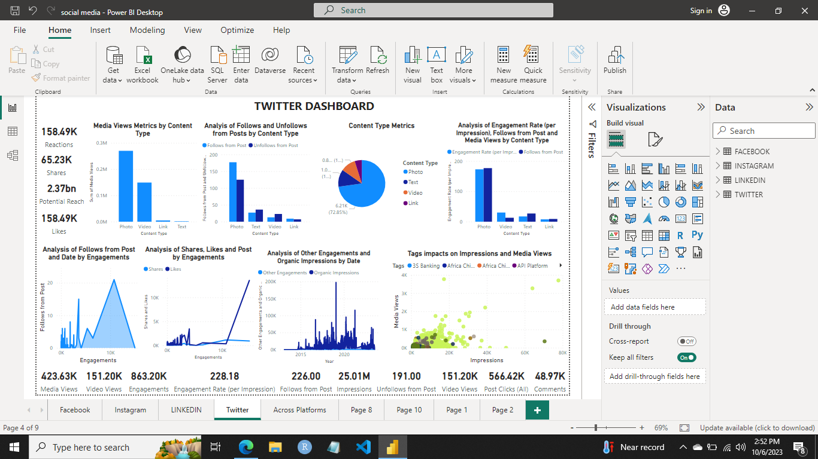

**Section 2: Exploratory Data Analysis**

* **Engagement Trend:** Post Engagement across various social media platforms reveals that Facebook leads the pack in terms of engagement, followed by Instagram and Twitter. LinkedIn, on the other hand, records the lowest level of post engagement among these platforms.

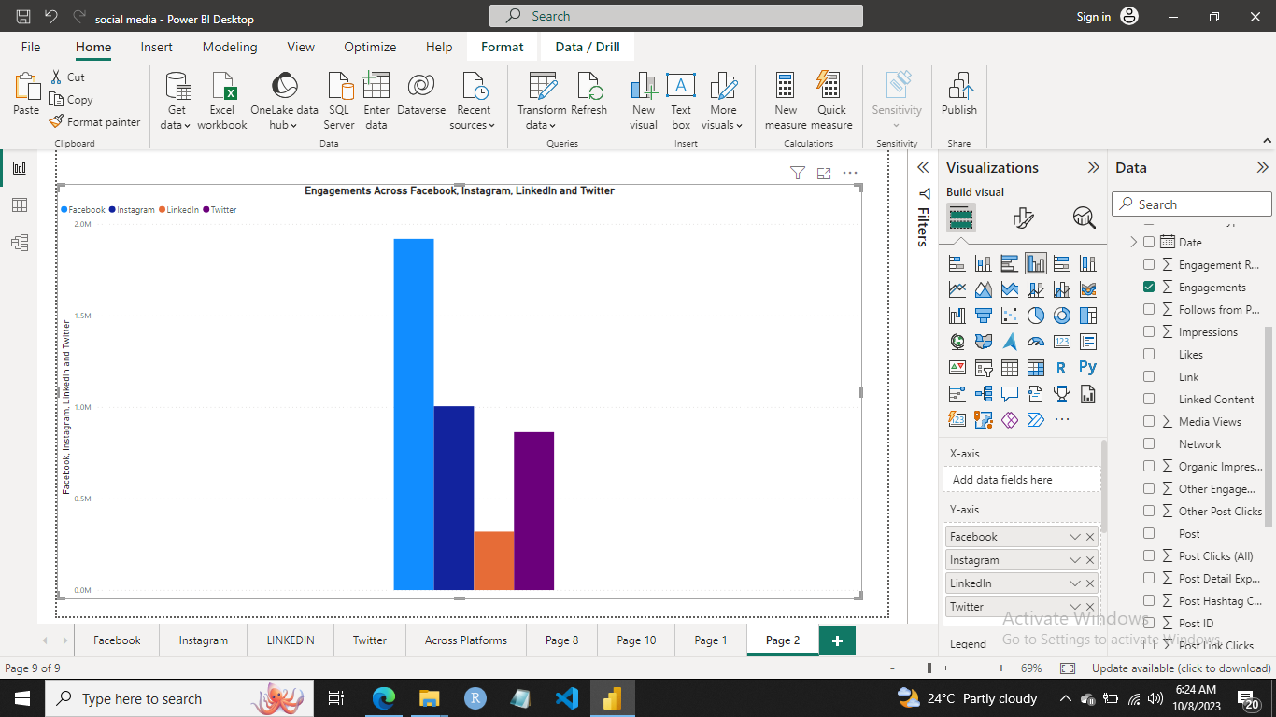

* **Engagement by Content Type:** An analysis of engagement by content type across Facebook, LinkedIn, Twitter, and Instagram distinctly highlights that photos lead in engagement on both Facebook and Twitter. Meanwhile, polls emerge as the content type with the highest engagement on LinkedIn, and videos take the top spot-on Instagram.

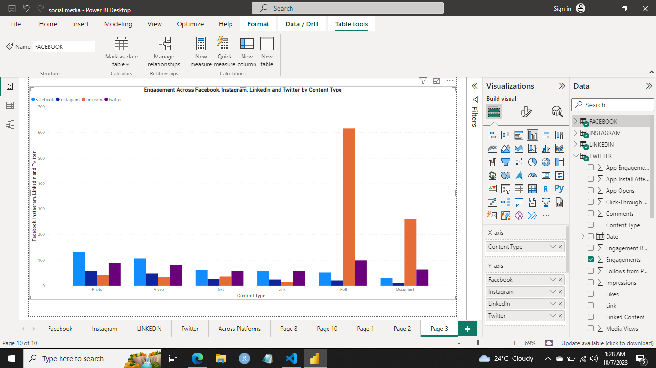

* **Reactions and Likes:** The analysis indicate that Reactions and Likes are most prevalent on Instagram, with Facebook following closely behind. Twitter also demonstrates a noteworthy presence in this regard, while LinkedIn records the lowest level of Reactions and Likes among these platforms.

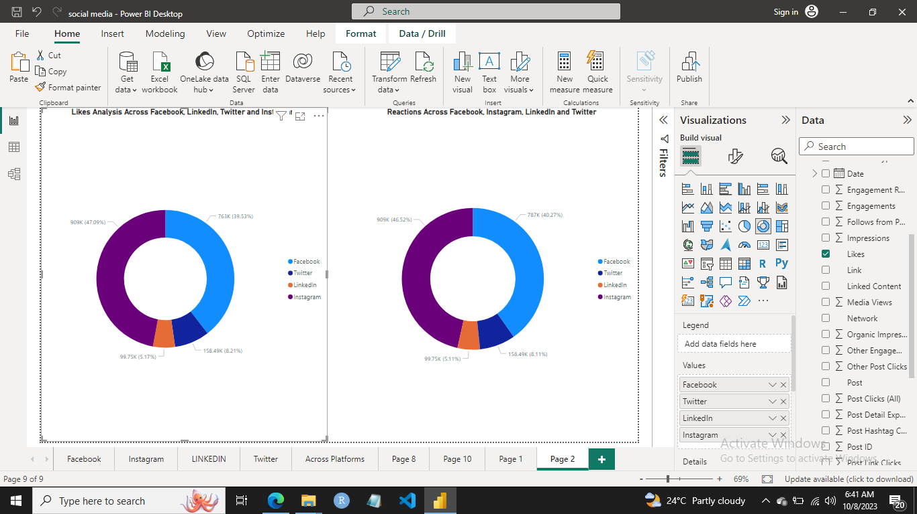

* **Video Views Insight:** Instagram leads the pack with the highest number of video views, followed by LinkedIn and Facebook, with Twitter recording the lowest number of video views among these platforms.

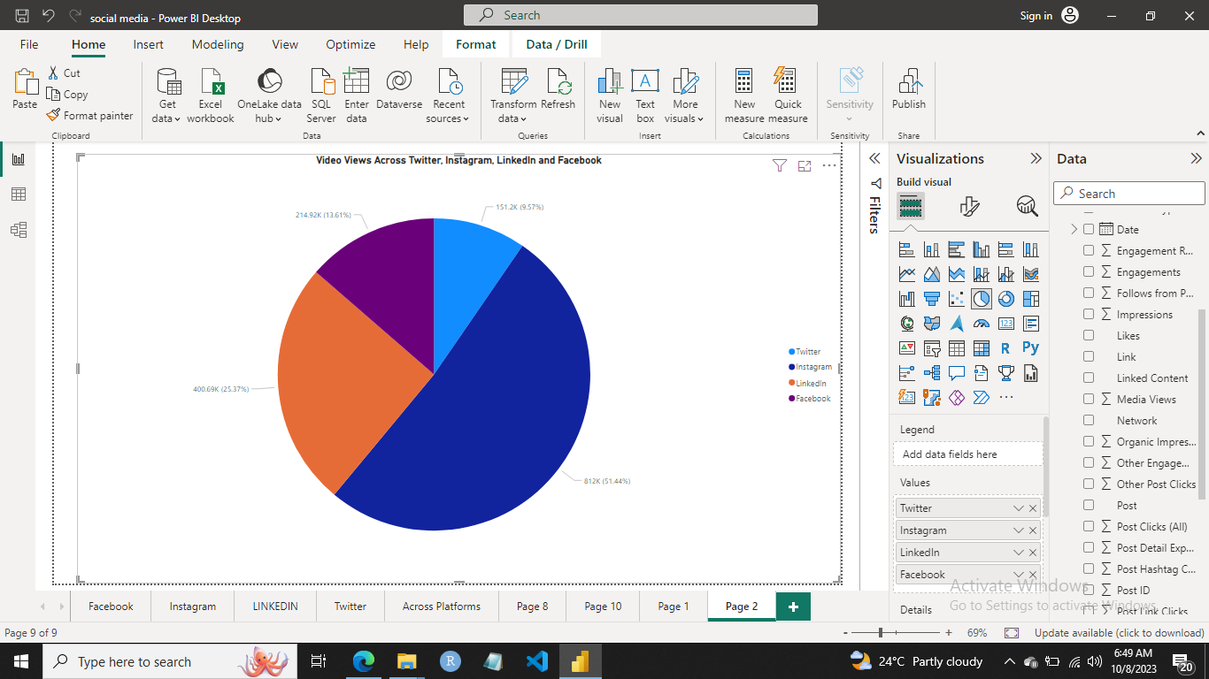

* **Engagement Analysis Highlights:**
* Engagements, Shares, and Impressions reach their peak on Facebook, establishing it as the dominant platform for these metrics.
* In terms of Shares across platforms, Facebook leads the way, closely trailed by Twitter, while LinkedIn records the lowest share count.
* Impressions are most extensive on Facebook, followed by Twitter and Instagram, with LinkedIn registering the lowest impressions among these platforms.

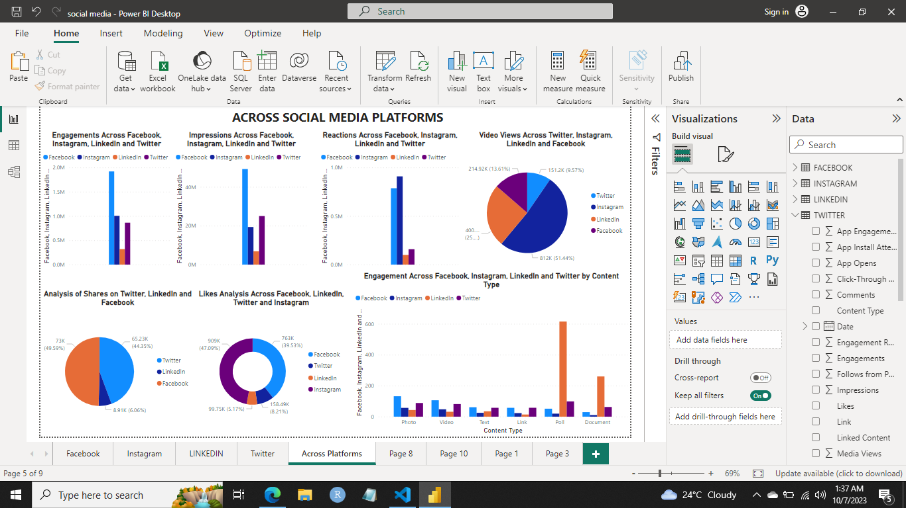

**Section 3: Posts Insights Command Line Interface**

The Post Insights Command Line Interface (CLI) is a Python-based tool designed to predict social media metrics, including engagements, impressions, reactions, likes, engaged users, subscribers, and shares. This CLI harnesses the power of a pre-trained machine learning model, utilizing two critical user inputs: content type and social network. With this tool, you can gain valuable insights into the expected performance metrics for specific content types on various social networks.

**Overview, Libraries and Prediction**

The CLI is built on essential Python libraries such as joblib, pandas, and scikit-learn. It seamlessly loads a pre-trained machine learning model from a saved file, aptly named "model.joblib". This model takes two user-provided inputs—content type and social network—to generate predictions. The results are elegantly organized in a dictionary format for user convenience.

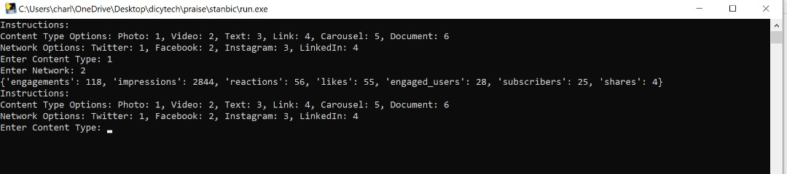

**Main Function**

* The CLI offers an intuitive user interaction experience.
* It prompts users to input their preferred content type and social network.
* Upon user input, the CLI promptly displays the predicted metrics, providing actionable insights.

**Usage Instructions and Error Handling**

Users are presented with a well-defined set of content type and social network options, simplifying their choices. Content type options encompass Photo, Video, Text, Link, Carousel, and Document, while social network options include Twitter, Facebook, Instagram, and LinkedIn.

To ensure a seamless experience, the CLI incorporates robust error-handling mechanisms. These mechanisms promptly catch exceptions and offer informative error messages, should any issues arise during usage.

**Recommendations**

1. **Leverage Instagram's May Engagement Trend:** Given the consistent trend of higher engagement in May, planning and scheduling most important content for this month should be considered. This could include major announcements, product launches, or campaigns.
2. **Optimize Posting Times on Instagram:** The most engaging hours on Instagram (2 PM, 10 AM, and 9 PM) should be utilized by scheduling posts for this time for maximum impact. Tailoring content release times to match these peak engagement hours can boost reach and interactions.
3. **Focus on Video Content:** Since video content on Instagram generates the highest reactions, engagements, and likes, more resources should be allocated to creating engaging video content. Consider diversifying content strategy with a mix of short clips, stories, and longer videos.
4. **Create Good Visuals on Facebook:**  On Facebook, where photo content receives the most likes and reactions, visually appealing content should be showcased through photos. Consider creating contents pertaining to accounts to engage audience.
5. **Leverage Polls on LinkedIn:** Given that polls receive the highest engagement on LinkedIn, incorporating polls into LinkedIn content strategy should be considered. Utilizing them to gather insights from audiences
6. **Twitter Engagement Strategy:** Capitalize on Twitter's engagement trends, with peaks at 7 AM and 11 PM. Scheduling important tweets during these hours to maximize reach and interactions. Additionally, focus on photo content as it garners the highest engagement.
7. **Machine Learning Tool:** Utilizing the Posts Insights Command Line Interface (CLI) to predict social media metrics. Its efficient use and analysis would provide insights to refine content strategy.
8. **Content Type Diversity:**  Diversification of content types to align with platform preferences. For example, use polls on LinkedIn, photos on Facebook and Twitter, and videos on Instagram. This ensures that content type resonates with the preferences of each platform's audience.
9. **Historical Trends:** Understanding historical engagement trends and spikes is beneficial. Leveraging insights from successful years and months to plan content calendar. For instance, consider running anniversary campaigns or promotions during periods of historical high engagement.
10. **Consistent Monitoring:** Continuously monitor engagement trends and adjust strategy accordingly. Social media is dynamic, adaptability and responsiveness to changing trends is essential for long-term success.

**Conclusion**

In the ever-evolving landscape of social media, harnessing data-driven insights is paramount to building a successful digital presence. This exploration of social media - LinkedIn, Instagram, Facebook and Twitter – datasets and the utilization of the Posts Insights Command Line Interface (CLI) have provided invaluable guidance for optimizing our approach across various social media platforms.

The findings indicate that each platform has its unique nuances and preferences. Instagram shines in May, with a surge in engagements, emphasizing the importance of strategic content planning during this period. Twitter exhibits a remarkable upward trend, with optimal engagement hours at 7 AM and 11 PM, making it crucial to align content releases with these hours for maximum impact. Facebook resonates most with photo content, reinforcing the need to showcase visually appealing stories.

LinkedIn's preference for polls and its significant growth in engagement in 2022 present exciting opportunities for engaging with a professional audience. Across the board, video content consistently garners the highest reactions, engagements, and likes, urging us to prioritize its creation.

The Posts Insights CLI proves to be a valuable tool for predicting social media metrics and gaining insights into content performance. Ensuring its efficient use within team and continually enhancing its error-handling mechanisms is essential to sustaining data-driven strategy.

In summary, the social media insights have unveiled a roadmap for success. By tailoring content strategy to platform preferences, embracing the power of video, and adapting to engagement trends, the organization is poised to maximize impact across social media platforms, fostering deeper connections with audience and achieving digital goals.

This Python script serves as a simple yet effective tool for predicting social media metrics based on content type and social network choices. It utilizes a pre-trained machine learning model to provide insights into expected performance metrics, which can be valuable for social media content planning and strategy. Users can continue using the tool to gain predictions for different content types and networks.